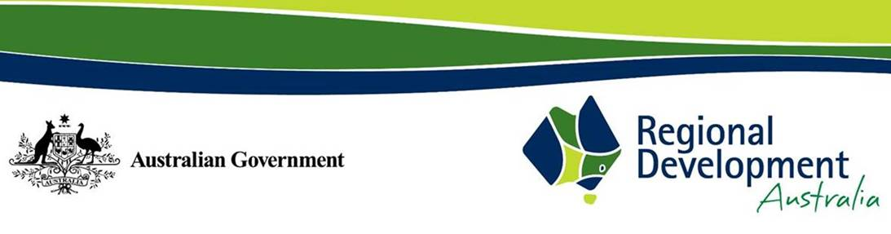
Attachment 3.C
2025-2026 ANNUAL REPORT ON OUTCOMES
REPORTING TEMPLATE FOR REGIONAL RDAs

DUE DATE: 30 SEPTEMBER 2026

For further guidance on what information should be included in your report on outcomes, including mandatory items, please refer to:
- Section 1.3, 3.1 and 3.3 of the Better Practice Guide
- Clause 10 and Items A.3.3, A.3.4 and A.4 of Schedule A of the Funding Agreement

- Annual Report on Outcomes must be signed and dated (this item is mandatory)

Signature:

Certified by (print name and position):

Date:

- Chair’s foreword or executive summary
This section should include:

- A short overview of progress made implementing your business plan
- A list of your successes, significant events and achievements
- Whether the key focus identified in your business plan changed throughout the year
- An overview of how the skills of Committee members and employees were used to deliver the activities identified in the business plan

- Strategic context and regional priorities
This section should include:

- Reference to the region’s strategic priorities and key business activities that were included in the business plan
- Reference to how the activities your RDA has undertaken relate to the strategic priorities of the region and all levels of government

- Annual Work Plan
This section should:

- Reference the work undertaken that has added value to your region – how did you make a difference
- Include details of activities not achieved, problems experienced, lessons learned and what challenges these have created
- Detail work undertaken in partnership with commonwealth, state and local governments, the private sector and non-governmental organisations
- Detail collaborations with other RDA Committees and other entities
- Detail external funding received, not included as a third-party arrangement

- Guidance for Victorian and South Australian Committees (this item is mandatory)
State governments jointly fund Committees in these jurisdictions. Local governments also provide funding to South Australian Committees. It is acknowledged that for these states, some outcomes and performance indicators sought by the Victorian Government, the South Australian Government and local governments (as appropriate) will be the same, and others may be different but complementary.
Victorian and South Australian Committees must provide commentary/details regarding:

- The mandatory business plan requirements outlined in Section 3.2
- Activities that have contributed to the achievement of shared outcomes and performance indicators, as well as those that are state and local government-specific must be easily identifiable from the reporting provided on Committee-specific activities

- Communications Strategy
This section should:

- Consider your communications strategy provided with your annual business plan and how it has supported the achievement of outcomes and performance indicators throughout the year
- Detail what communications platforms you used throughout the year (e.g. website, social media, newsletters) and provide relevant quantitative data, including statistics on engagement, reach etc.

- Case Studies (this item is mandatory)
You must include at least 2 written case studies with the Report on Outcomes.
Case studies are extremely valuable for the Department, as they assist in promoting Committees’ work to Ministers, government agencies and community stakeholders. One Case Study, nominated by the RDA, will be published each year on the RDA website.
Case Study 1 (this is the nominated case study to be published on the RDA website)

Should:

- Not be longer than one A4 page in text
- Include images to accompany the case study in .jpg; .gif; or .png file. If providing more than one image, please nominate the preferred image to be published
- Focus on key achievements during the reporting period
- Demonstrate examples of where the Committee has made a difference in its region
- Be new case studies (i.e. not used previously in an Annual Report on Outcomes) unless there has been considerable advancement in the project’s status
- Include links to relevant accompanying materials, including videos
- Only contain personal information of individuals over the age of 18 years whose informed consent to use the personal information has been provided

Case Study 2

Should:

- Focus on key achievements during the reporting period
- Demonstrate examples of where the Committee has made a difference in its region
- Be new case studies (i.e. not used previously in an Annual Report on Outcomes) unless there has been considerable advancement in the project’s status
- Include images and/or videos
- Only contain personal information of individuals over the age of 18 years whose informed consent to use the personal information has been provided

- 2025-2026 Professional Development Program – Round Six (this item is mandatory)
Under the terms of the variation, RDAs are required to provide the Department with confirmation that the agreed Professional Development activities were completed and that the stated outcomes were achieved.

If RDAs did not take up the offer for Round Six PDP funding, please comment N/A.

This section should include:

- Description of activity undertaken
- Date and location of activity
- Names of committee members and staff that attended activity
- Outcomes of activity undertaken

- Third Party Arrangements (this item is mandatory)
The Funding Agreement (Clause 11, Not applicable to IOT RDO and Victorian Funding Agreements) states that Committees must include a listing of all Third Party Arrangements, regardless of value, in each Annual Report on Outcomes. Refer to Section 1.8.1, 3.3 and 4.5.2 of the Better Practice Guide for further guidance of third-party arrangements.

If RDAs do not have any Third Party arrangements in place, please comment N/A.

Organisation Name | Description of activity being undertaken | Contract start and end dates | Contract value and payment milestones | Activity progress to date | Details of how any surplus funds generated will be used

10. Outcomes and Performance Indicators Tables for Regional RDAs (this item is mandatory)

Use the funding agreement outcomes and performance indicators as the starting point for detailing activities and reporting performance.

This section provides the means for a Committee to advise of its intended activities and performance indicators (as part of the business plan) and to report on those activities and performance indicators (as part of the annual report).

Part 1 of the Outcomes and Performance Indicators table was completed as part of your Annual Business Plan and Budget. This included your RDAs top 5 strategic priorities and top 5 key business activities.

Copy your RDA’s top 5 strategic priorities, top 5 key business activities and the Outcomes and Performance Indicator table that were included in your Annual Business Plan into this section. Then complete your top 3 key achievements for the year (refer below) and Part 2 of the Outcomes and Performance Indicators table.

Please complete the following:

From the Annual Business Plan and Budget: the top 5 strategic priorities were:

From the Annual Business Plan and Budget: the top 5 key business activities were:

For the Annual Report on Outcomes: provide summary of top 3 key achievements for the year:

